PROJECT 11 : SUDOKU

Program Description

The program will prompt the user for the filename of the game he or she is currently working on and display the board on the screen. The user will then be allowed to interact with the game by selecting which square he or she wishes to change. While the program will not solve the game for the user, it will ensure that the user has not selected an invalid number. If the user types 'S' in the prompt, then the program will show the user the possible valid numbers for a given square. When the user is finished, then the program will save the board to a given filename and exit.

Algorithms

computeValues(int row, int col)

// set size of not possibles for each row , col and box

SET rowCount , colCount, boxCount to 1

// create an array for row, col and box NOT possible values

SET rowNotPossible TO createArray

SET colNotPossible TO createArray

SET *boxNotPossible TO createArray

// create array and return pointer

Int *createArray(size)

SET *p to new array [size +1]

RETURN p

// takes an array , and the current size and expands the array by 1

Int expandArray(*array, size)

SET tempArray IS new array +1

FOR 0 to size

tempArray[i] IS array[i]

DELETE array

array IS tempArray

RETURN *array

FOR 0 to 8i++ // loop through row / columns

// check rows if not 0

IF board[row][i] IS != 0

rowNotPossible[rowCount] IS board[row][i]

expandArray(rowNotPossible, rowCount)

rowCount++

//check col if not 0

IF board[col][i] IS != 0

colNotPossible[colCount] IS board[col][i]

expandArray(colNotPossible, colCount)

colCount++

// this is where the real magic happens…. Find out the beginning of the box

SWITCH row % 3

CASE 0

rowBlockStart IS row

CASE 1

rowBlockStart IS (row – 1)

CASE 2

rowBlockStart IS (row – 2)

SWITCH col % 3

CASE 0

colBlockStart IS col

CASE 1

colBlockStart IS (col – 1)

CASE 2

colBlockStart IS (col – 2)

// loop through box and see if its not 0

FOR rowBlockStart TO (rowBlockStart + 2)

FOR colBlockStart TO (colBlockStart + 2)

IF board [rowBlockStart] [colBlockStart] != 0

boxNotPossible[boxCount] IS board [rowBlockStart] [colBlockStart]

boxCount++

valueCount IS 0

FOR 1 to 9 i++

FOR 0 to boxCount j++

boxPossible IS TRUE

IF i == boxNotPossible[j]

boxPossible IS FALSE

FOR 0 to rowCount j++

rowPossible IS TRUE

IF i == rowNotPossible[j]

rowPossible IS FALSE

FOR 0 to colCount j++

colPossible IS TRUE

IF i == colNotPossible[j]

colPossible IS FALSE

IF boxPossible && rowPossible && colPossible

possibleValues[valueCount]

valueCount++

RETURN *possibleValues

interact()

DO

exit IS false

SWITCH getChoice()

CASE ?

DisplayMenu()

CASE D

displayBoard()

CASE E

editSquare()

CASE S

showPossibles()

CASE Q

exit IS true

WHILE !exit

Structure Chart

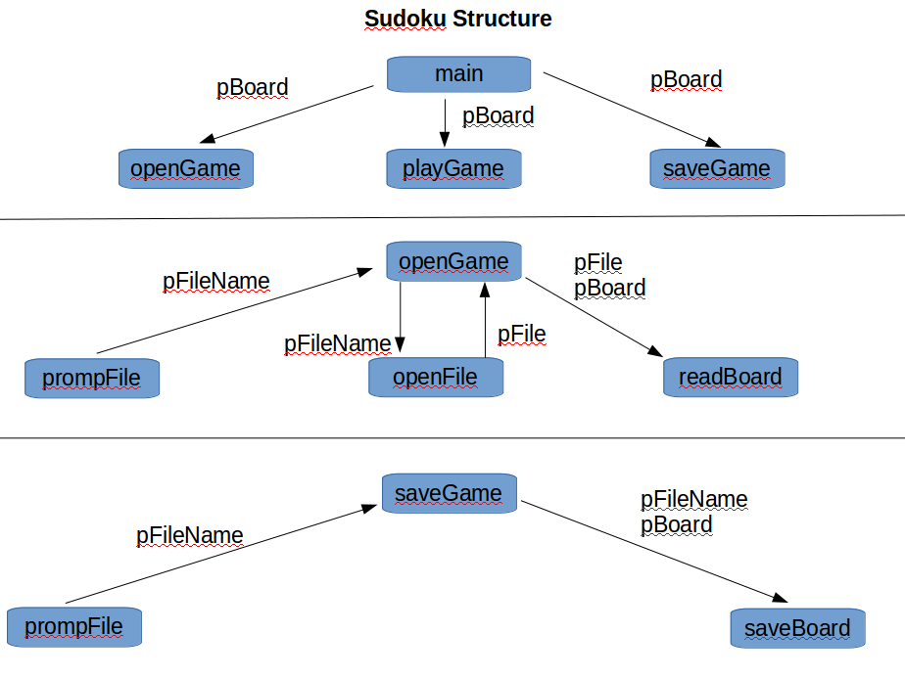

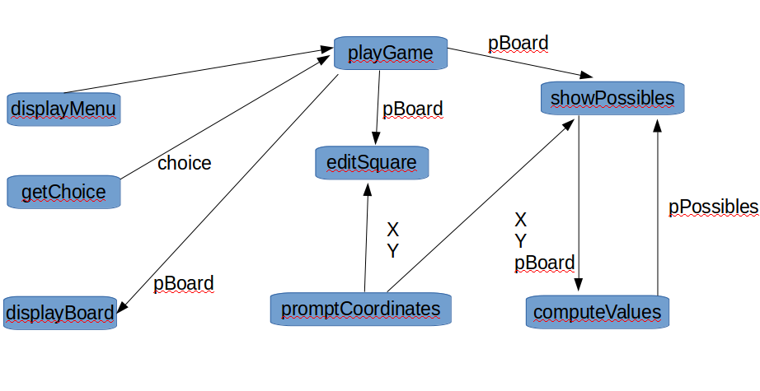

### Grading

The grading criteria are:

|  |  |  |  |  |  |
| --- | --- | --- | --- | --- | --- |
|  | Exceptional 100% | Good 90% | Acceptable 70% | Developing 50% | Missing 0% |
| Structure Chart 40% | Design is elegant and well thought out | Design will solve the problem | The structure chart is incomplete or has a serious defect making the solution unworkable | Structure chart not showing the connection between the functions, name of the functions, or the data passed between the functions | No structure chart |
| computeValues(): Rules are enforced 30% | The most efficient solution has been found | All the rules are correctly represented in the pseudocode | A bug exists or not all the rules are enforced | Pseudocode insufficient quality to help in the design process | No rule logic in the computeValues()function |
| computeValues(): List possible values 10% | Design is elegant and well thought out | All possible values will be listed for a given square on the board | A bug exists in the algorithm or does not solve all the problems | Pseudocode not detailed enough to tell if the problem has been solved | No display logic in the computeValues()function |
| interact() 20% | The most elegant solution has been found | The function will allow the user to interact with the game | The design fails to do one of the following: · Select an option · Execute the option specified · Continue looping until the user is finished | Pseudocode insufficient quality to help in the design process | No pseudocode for the interact function |

You are required to attach the [**above rubric**](https://content.byui.edu/file/cddfb9c0-a825-4cfe-9858-28d5b4c218fe/1/Ponder/124.11.Project.Rubric.pdf) to your design document. Please self-grade.